# LAB EXPERIMENT 05

# Implementation of Gauss-Jacobi Method for Solution of System of Linear Equations

# Objective:

To find the solution of system of linear equation using Gauss-Jacobi Method through MATLAB

## Theory:

Given a general set of  equations and  unknowns, we have







If the diagonal elements are non-zero, each equation is rewritten for the corresponding unknown, that is, the first equation is rewritten with  on the left hand side, the second equation is rewritten with  on the left hand side and so on as follows



These equations can be rewritten in a summation form as





.



Hence for any row ,



Now to find ’s, one assumes an initial guess for the ’s and then uses the rewritten equations to calculate the new estimates simultaneously. At the end of each iteration, one calculates the absolute relative approximate error for each  as



where is the recently obtained value of , and  is the previous value of .

When the absolute relative approximate error for each *xi* is less than the pre-specified tolerance, the iterations are stopped.

## Problem Statement:

# Implement Guass-Jacobi Method on the following linear system of equation through MATLAB:

## MATLAB Code:

|  |
| --- |
| clc, clear all  %% Defining Variables and Equation constant as a matrix    yes = 0;  c = 2; d = 0; e = 0; iterations = 0;  xi = 0; yi = 0; zi = 0;    A = [26 6 -1; 6 15 2; 1 15 50];  B = [85; 72; 110];    [R,C] = size(A);    %% Program    for a = 1:R  row = abs(A(a,:));  total = sum(row) - row(a);    if row(a) <= total  fprintf("Error, Dimensional Analysis cannot be verified\n")  yes = 1;  end  end    if yes == 0  InvA = A;    InvA(1,2) = A(1,2) * -1;  InvA(1,3) = A(1,3) * -1;    InvA(2,1) = A(2,1) * -1;  InvA(2,3) = A(2,3) * -1;    InvA(3,1) = A(3,1) * -1;  InvA(3,2) = A(3,2) * -1;    P = [B InvA];    Q = P;  for b = 1:R  Q(b,:) = P(b,:) / P(b,c);  c = c + 1;  end    x = xi; y = yi; z = zi; xOld = 0; yOld = 0; zOld = 0;  while e ~= 1  xNew = (Q(1,1)) + (Q(1,3) * y) + (Q(1,4) * z);  yNew = (Q(2,1)) + (Q(2,2) * x) + (Q(2,4) * z);  zNew = (Q(3,1)) + (Q(3,2) * x) + (Q(3,3) * y);    xNew = round(xNew,4); yNew = round(yNew,4); zNew = round(zNew,4);    if xNew == xOld && yNew == yOld && zNew == zOld  e = 1;  end    xOld = xNew; yOld = yNew; zOld = zNew;  x = xNew; y = yNew; z = zNew;    iterations = iterations + 1;  %fprintf("x = %.4f, y = %.4f, z = %.4f, Iteration = %.0f\n", x, y, z, iterations)  end    fprintf("The roots using Jacobi Method were found out to be the following in %.0f iterations", iterations)  fprintf("\nx = %.4f, y = %.4f, z = %.4f \n", x, y, z)  end |

## Results:

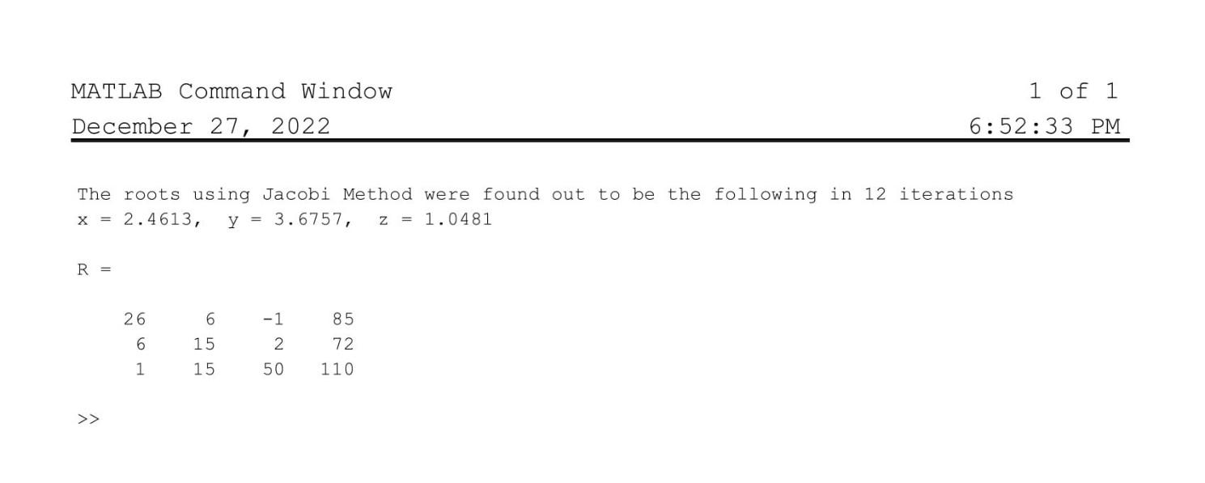

## Discussion

Comments will be made on the following

1. Write the three Numerical methods to solve the linear system of equations?

1. Which methods is converging faster Guass-Jacobi method and Guass-Siedel method?